STUDENT RECORD MANAGEMENT SYSTEM

INTRODUCTION
Structured programming is a programming approach that organizes code into logical and reusable sections using functions, loops, and decision-making structures. This assignment focuses on developing a terminal-based Student Record Management System using Python. The system is designed to solve challenges related to student information management in schools and colleges in Sierra Leone.

The application allows users to add student records, display records, search for students, and calculate average scores. The system demonstrates the use of structured programming principles such as variables, data types, loops, decision structures, and functions.

- PROBLEM DESCRIPTION
Many schools and small educational institutions in Sierra Leone still manage student records manually using notebooks and paper files. This method creates several problems including:

- Loss or damage of records.
- Difficulty in searching for student information.
- Slow processing of student results.
- Errors in calculating student averages.
- Poor organization of records.
Manual systems also consume time and make record management inefficient. Teachers and school administrators often struggle to maintain accurate and organized information.

This project aims to solve these challenges by creating a simple computerized Student Record Management System. The system stores student details digitally and performs calculations automatically.

- SYSTEM EXPLANATION
The Student Record Management System is a terminal-based Python application that allows users to manage student information.

The system performs the following functions:
1. Add student records.
2. Display all student records.
3. Search for a student by name.
4. Calculate average marks.
5. Exit the system.
The program uses loops to allow multiple records to be entered continuously. Decision structures such as if, elif, and else are used to control the program flow.
Functions are used to divide the program into smaller reusable modules, making the code easier to understand and maintain.
The application is simple, user-friendly, and suitable for educational institutions with limited resources.

- STRUCTURED PROGRAMMING APPLICATION
The project applies structured programming principles in the following ways:

Variables and Constants
Variables are used to store student information such as:

- student_name
- student_id
- marks
- average
Constants can also be used where necessary, for example:
PASS_MARK = 50

4.2 Data Types
Different data types are used in the program:

Data Type Example
String Student name
Integer Student age
Float Average score
List Collection of student records
Dictionary Individual student details

Decision Structures
The program uses if, elif, and else statements to make decisions.

Example:
If average >= 50 → student passes.
Else → student fails.

Iteration (Loops)
Loops are used to:
- Display the menu repeatedly.
- Process multiple student records.
- Display all records.
The while loop keeps the system running until the user decides to exit.

Functions (Modularity)
Functions divide the program into smaller sections.

Functions used include:
- add_student()
- display_students()
- search_student()
- calculate_average()
This improves readability, maintenance, and code reuse.

- SDG RELEVANCE
This project supports the United Nations Sustainable Development Goal 4:
SDG 4 – Quality Education
The system helps improve educational management by providing a simple digital solution for handling student records. It promotes efficiency, accuracy, and better organization in schools.
The project also encourages digital transformation in educational institutions in Sierra Leone.

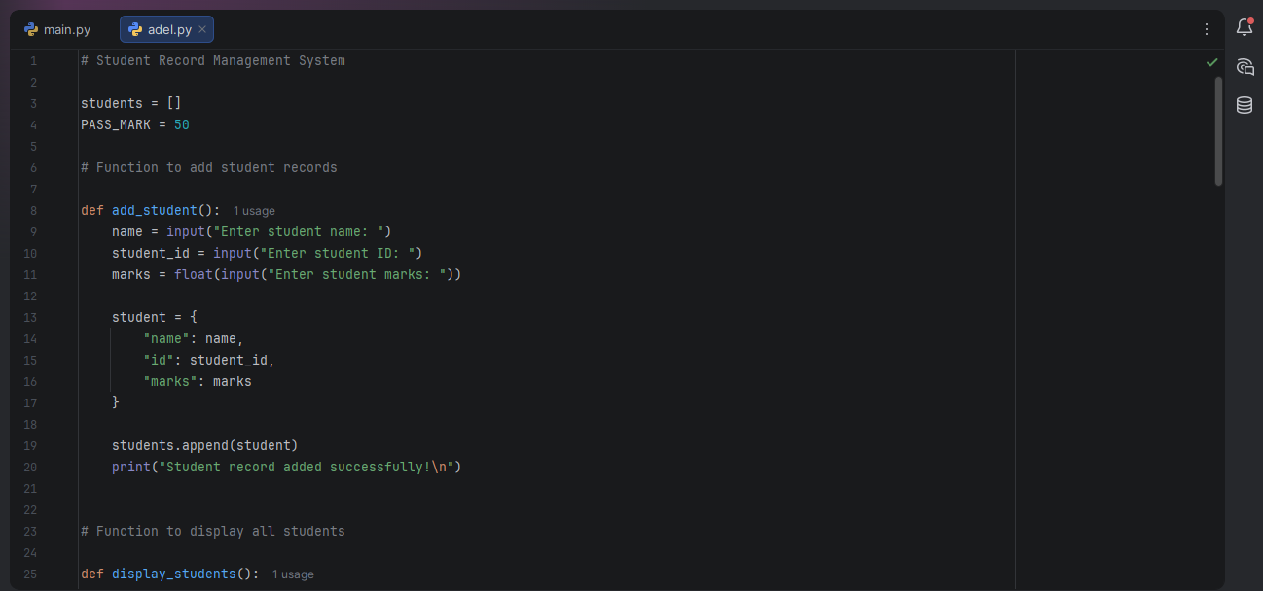
- HOW STRUCTURED PROGRAMMING PRINCIPLES WERE APPLIED

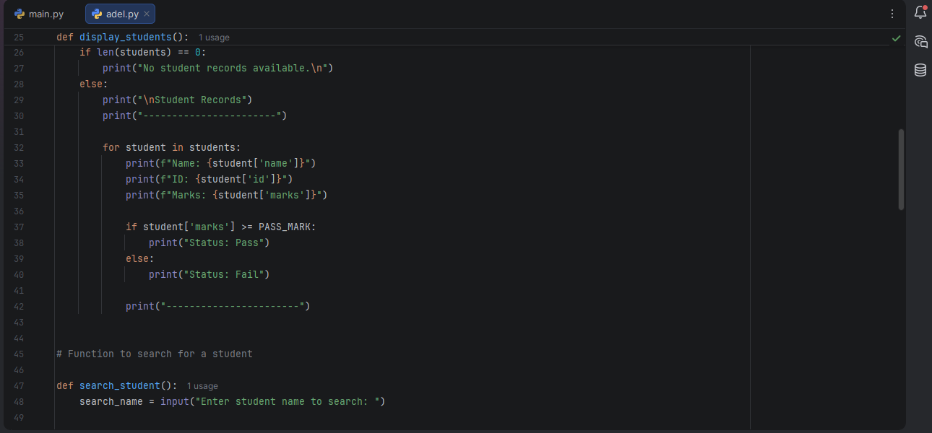

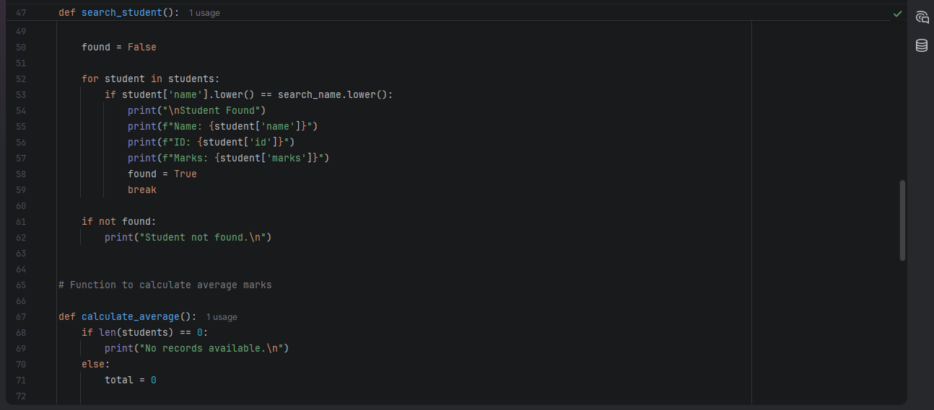

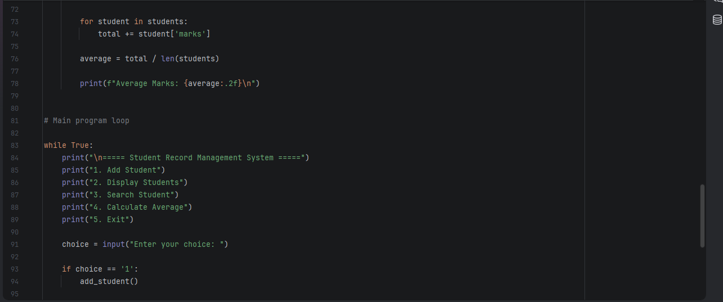

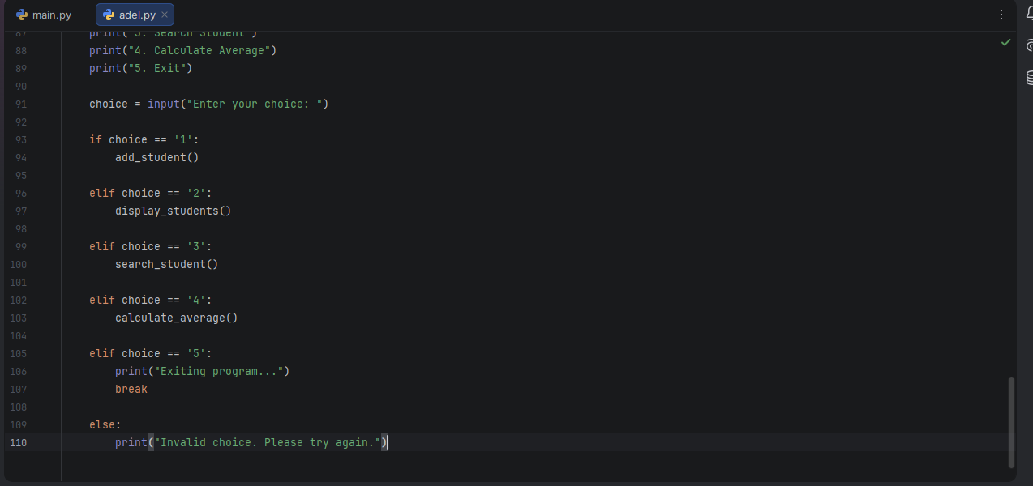

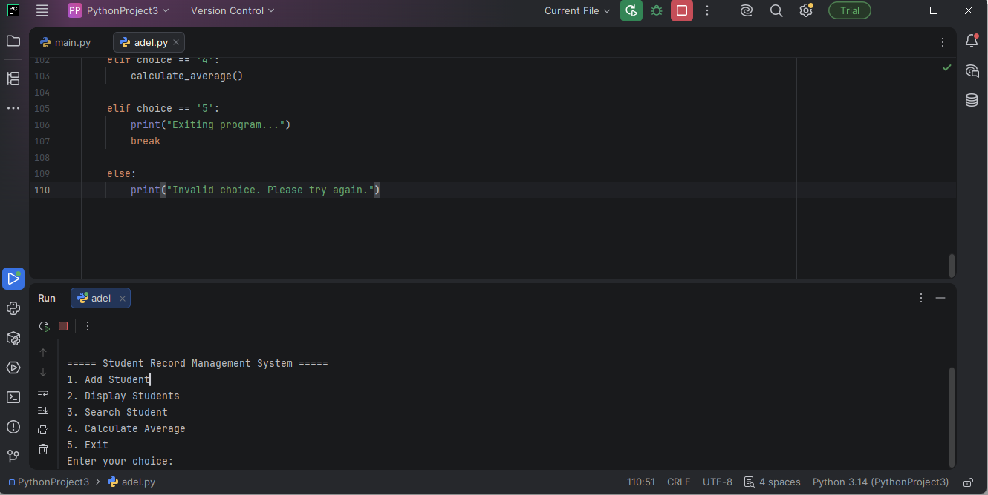

4. GITHUB EVIDENCE
- Git status: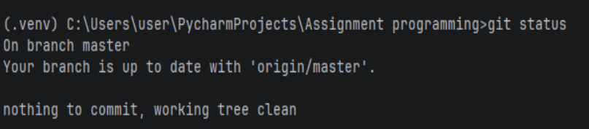

- Git commit: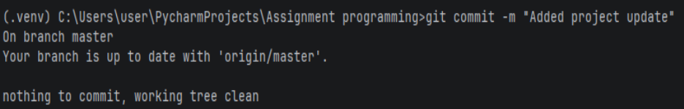

- Git push: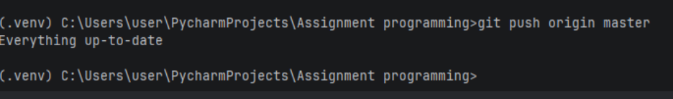

- Git repository link:
https://github.com/johnadelsesay-sys/Student-Record-Management-System

